PRESS QUOTES
CD/LP/Track Review
Ilia Skibinsky: The Passage (2013)
By DAN MCCLENAGHAN, Published: February 1, 2013

The youthful saxophonist/composer Ilia Skibinsky strikes a thoughtful pose, gazing down at his horn on the nicely designed cover of his debut, The Passage. The substitution of a much older visage would have been believable, given the depth and beauty of the playing, and the writing on the set's nine original compositions.
Born in Russia, but moving with his family to Israel in 1993, where he performed with the best of his adopted country's jazz artists, Skibinsky succumbed to the lure of the States in 2007, to attend New York's New School University on a scholarship.
Skibinsky's resume brims with television and show business work: Israeli adaptations of American Idol and Dancing with Stars, as well as working over 500 shows with Cirque Du Soleil, but the music on The Passage has a modern jazz sheen. Skibinsky, playing alto and soprano saxophones, leads a piano/bass/drums rhythm team, with guest slots for guitar, trumpet and tenor sax.
Opening with a one/two punch of "Part One" and "Two" of the title track, and joined by guest Matthew Silberman on tenor sax, the music has a sharp edge and an urgency, featuring long melodic lines and gliding rhythms.
Skibinsky's compositional voice is distinctive and consistently engaging. "Seven Skies" has a Middle-Eastern tint, with the leader's beautiful, rich tone on soprano sax up front and center, while "Beyond the Sun," a plaintive ballad, showcases Skibinsky's more introspective side and his gorgeous, hollow tone on alto saxophone. "Translucent" opens with a piano shimmer, leading into some striking two-horn harmony, with tenor man Silberman sitting in again.
A highlight of this superb debut is "When We Forget," featuring Joe Deninzon's string contributions, with Skibinsky playing piano as well as alto. The mood here is one of classical grandeur with a brooding, late night jazz tint.
With nine tunes and a mix of guest slots, The Passage could have become an unfocused mish-mash of a set, but rising star Skibinsky's sharp artist vision and stellar tune-smithing hold things together as a cohesive statement, on this excellent debut.
Track Listing: The Passage, Part 1; The Passage, Part 2; Seven Skies; When We Forget; Beyond teh Sun; Translucent; Distant Lights; Dorian Ways; What Words Cannot Express.
Personnel: Ilia Skibinsky: alto and soprano saxophones, piano (4); Glen Zaleski: piano; Edward Perez: bass; Colin Stranahan: drums; Mike Moreno: guitar (1, 2, 5); Matt Jodrell: trumpet (1, 2, 6); Matthew Silberman: tenor saxophone (1, 2, 6); Joe Deninzon: strings (4).
Record Label: Mythology Records
http://www.allaboutjazz.com/php/article.php?id=43802#.UWWCc3CzMvY

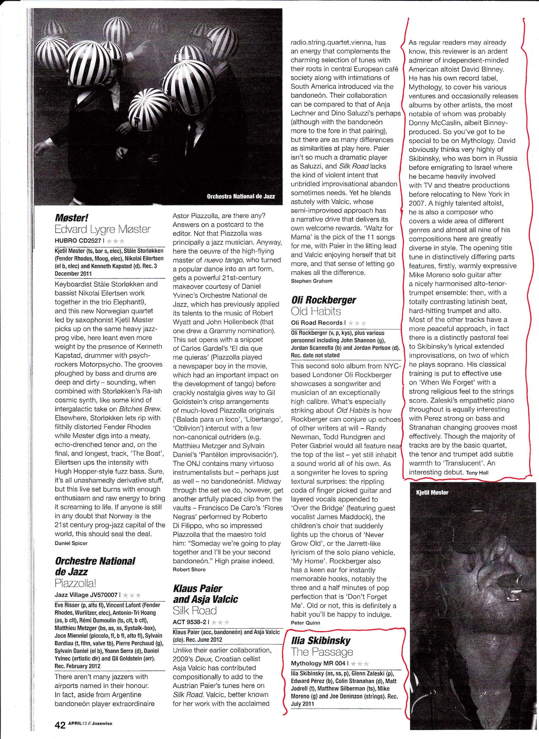

MUSICAL NOTES

Entertainment
WRITTEN BY ESTHER CALLENS
THURSDAY, 28 FEBRUARY 2013 12:20

Newly released on David Binney’s Mythology Records is a fresh new sound by a refreshingly, energetic artist. The title of this marvelous collection is The Passage and its creator is Israeli/Russian saxophonist Ilia Skibinsky. Presenting the level of quality that very few seasoned composers possess, Ilia Skibinsky has overtaken the jazz genre by storm in a very short time.
The Passage consists of nine original compositions. Although the album has a thoroughly modern feel, the arrangements run the gamut. From the classical strings presented on "When We Forget" to the swinging improvisational skills displayed on the title track part 2, Ilia Skibinsky has proven he is a young man with an old soul grounded in music. He is an outstanding artist to watch.
Ilia Skibinsky is a saxophonist, pianist, producer, and composer. He was born in Russia and he immigrated to Israel in 1993. While in Israel, he performed on a number of television shows that included the Israeli adaptions of Dancing with Stars and American Idol. In 2007, he moved to New York and he has since performed with Bobby Sanabria, Larry Graham, Joanne Brackeen and others.
–––––––––––––––––––––––––––––––––––
Available this week is a new recording by guitarist duo Mark Kleinhaut and Neil Lamb. Jones Street is the title of this new collection that’s released through Invisible Music. Offering a wonderful collaboration between Kleinhaut and Lamb, Jones Street is just simply a great jam session.
The music on this album is easy, uninhibited and not rushed. Perhaps this is why these two Maine natives (Kleinhaut and Lamb) ended up laying down these tracks while on vacation. A historic 19th century structure in Savannah, Ga. happens to have been the makeshift recording studio for the 10 tracks collective. Consisting of bop, bluesy, ballad, you name it – Jones Street offers a surprising variety. At any rate, if this is the result of two guys just hanging out while playing, then they have set the marker high for in-studio recording.
http://www.birminghamtimesonline.com/index.php?option=com_content&view=article&id=10974:musical-notes&catid=65:entertainment&Itemid=121

Born in Russia, raised in Israel, saxophonist/composer Ilia Skibinsky is a young man who has not rushed onto the scene. While still under 30, Skibinsky has played in pit bands for numerous Israeli productions, toured with Cirque du Soleil, written soundtracks for television documentaries, and studies at the New School in New York City (he also studies with Joel Frahm). "The Passage" (Mythology Records) is his debut as a leader and is quite a mature statement. The core band features Glenn Zaleski (piano), Edward Perez (bass) and Colin Stranahan (drums) plus the trumpet of Matt Jodrell and tenor saxophone of Matthew Silberman on 3 tracks as well as contributions from guitarist Mike Moreno on 3 cuts. Russian-born violinist Joe Deninzon (leader of the fusion-jazz group Stratospheerius) plays Skibinsky's lovely string arrangement on the handsome ballad "When We Forget." " Handsome" is the proper word to describe the bulk of this music; these are well-constructed compositions that have strong melody lines and smart arrangements. Yet, there is a fire burning beneath the 2-part title track that opens the program. Zaleski's hypnotic piano chords lead in bass and drums while Skibinsky's alto shares the melody line with Moreno's guitar. Jodrell and Silberman add their "voices" to the mix. The first solo belongs to Moreno, his rippling lines moving easily over the active rhythm section (Stranahan stokes the energy here without great volume.) "Part 2" comes in like a lion, the propulsive bass and drums driving the soloists (arranged in a round-robin "call-and-response").

The leader does not really step into the solo spotlight until the 3rd track, "Seven Skies." Here, Skibinsky overdubs alto and soprano saxophones for the opening melody before stepping out on the higher reed for his solo. Zaleski's excellent counterpoint and Stranahan's active drumming stand out as does the pianist's exploratory solo. When the leader returns, he executes a short but sparkling dialogue/dance with the drummer before taking off for a second excellent solo. The spirit of Ralph Towner's music floats through "Distant Lights", the melody rising over the rhythm section before stopping for Perez's fine bass solo; Zaleski is next and his melodic phrases usher in the alto solo which occurs over a Brazilian-influenced rhythm. Skibinsky's phrases hop, skip and fly above the rhythm section, reminding this listener of Miguel Zenon. Moreno's guitar weaves around the alto on the slow yet intense "Beyond the Sun" - in the midst of both the guitar and flowing alto solos, one should also pay close attention to the "conversation" in the rhythm section. Skibinsky returns to soprano saxophone for "Dorian Ways", a multi-sectioned piece with an irresistible rhythmic drive, rippling melody line (more overdubbing from the leader) and outstanding piano work. The soprano solo moves effortlessly over the dynamic rhythms, the pure sound of the higher notes dancing along with the drums. The program closes with "What Words Cannot Express", an emotional ballad with another fine bass spotlight as well as excellent cymbal and brushwork.

The more one listens to "The Passage", the more impressive the project becomes. Ilia Skibinsky shows his ability to compose, arrange, play and direct in a way that stands out among the myriad releases of the early weeks of 2013. This excellent CD stands up well next to the new releases from Chris Potter and Wayne Shorter, displaying a maturity of musical understanding similar to those fine musicians. I'd love to hear this music live. For more information, go to www.iliaskymusic.com.

POSTED BY CULTURECREATURE (RICHARD B. KAMINS) AT 6:07 AM
LABELS: CD REVIEWS
http://steptempest.blogspot.co.il/2013/02/a-time-to-dance-time-to-grow.html

Ilia Skibinsky: The Passage (2013)
By DAN BILAWSKY, Published: January 24, 2013

Saxophonist David Binney's Mythology Records imprint is used sparingly, but when this maverick music man chooses to release albums under its banner, they tend to be bold and brimming with the excitement of the unknown; The Passage is no exception. With this debut, Russian-born/Israeli-bred/New York-based saxophonist/composer Ilia Skibinsky joins the elite Mythology roster, which includes post- modern piano marvel John Escreet and Binney himself. Skibinsky may not be as edgy as Binney, and his compositions may not be as aggressively exploratory as those of Escreet, but he shares both artists' love for the unorthodox.
The Passage presents nine original Skibinsky tunes which touch on all matter of style, sound and direction. While the majority of the album features a quartet, the two- part title track gives pause to admire some guests. Guitarist Mike Moreno, trumpeter Matt Jodrell and tenor saxophonist Matthew Silberman help Skibinsky in his efforts to address an exciting big picture compositional esthetic. The guests depart for "Seven Skies," which finds Skibinsky mixing elegiac tones with Middle Eastern ideals. His soprano saxophone work hits a nerve here, as he fleshes out emotional tides of aural thought. His only other soprano turn—"Dorian Ways"— presents a completely different player; one who takes flight in brilliant fashion. Skibinsky assumes the role of pianist on "When We Forget," which features strings and comes off more like a film score sequence than a modern jazz tune, but that's his only appearance at the keys.
While drummer Colin Stranahan's best work comes at the outset of the album, as he steers the group through the roller coaster title track(s), the virtues of Skibinsky's other band mates unfold across the program. Bassist Edward Perez can be found doubling thoughts with Skibinsky or pianist Glenn Zaleski, hitting a rhythmic stride with Stranahan, or simply going his own way. As a soloist, his work is thought-provoking and measured ("Distant Lights"). Zaleski is a probing solo presence, but one without any aggression or malice in his hands and mind; he simply likes to test the waters.
Skibinsky's diverse experiences, which include theater work, television, playing a Cirque Du Soleil show, and encounters with artists like pianist Joanne Brackeen, drummer Bobby Sanabria, and saxophonist David Sanchez, have given him a panoramic view of the music world that informs his compositions. The Passage is full of passion, promise, intelligence and strength; if that's not a musical formula for success, it's hard to say what is.
Track Listing: The Passage - Part 1; The Passage - Part 2; Seven Skies; When We Forget; Beyond The Sun; Translucent; Distant Lights; Dorian Ways; What Words Cannot Express.
Personnel: Ilia Skibinsky: alto saxophone, soprano saxophone (3, 8), piano (4); Edward Perez: bass; Colin Stranahan: drums; Mike Moreno: guitar (1, 2, 5); Matt Jodrell: trumpet (1, 2, 6); Matthew Silberman: tenor saxophone (1, 2, 6); Joe Deninzon: strings (4).
Record Label: Mythology Records
http://www.allaboutjazz.com/php/article.php?id=43757#.UWWN9XCzMvY

MYTHOLOGY
ILIA SKIBINSKY/The Passage: Here's a sax player that's bursting with so much energy and has been bubbling under for so long that he uses his debut album as a platform to be a resume piece showing off everything he can do at once. The trick that makes it click is he's got some special sauce up his sleeve that makes it flow as a record as opposed to a disparate collection of songs. Crafty! If you like to play a lot of music back to back, there's something about this set that hits you as a palette cleanser as you shift between courses. In it's own void, it's a breath of fresh air. Nicely done straight ahead jazz, this is first rate listening jazz that'll get heads bobbing and toes tapping as well. Smoking.
http://midwestrecord.com/MWR590.html

